Source

accuracy
The number of correct classification predictions divided by the total number of predictions. That is:
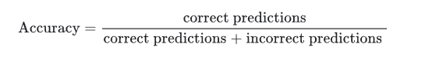

activation function
A function that enables neural networks to learn nonlinear (complex) relationships between features and the label.

bias term
An intercept or offset from an origin.

binary classification
A type of classification task that predicts one of two mutually exclusive classes:
- the positive class
- the negative class

categorical data
Features having a specific set of possible values.

classification model
A model whose prediction is a class.

clustering
Grouping related examples, particularly during unsupervised learning. Once all the examples are grouped, a human can optionally supply meaning to each cluster.

confusion matrix
An NxN table that summarizes the number of correct and incorrect predictions that a classification model made

ensemble
A collection of models trained independently whose predictions are averaged or aggregated. In many cases, an ensemble produces better predictions than a single model.

epoch

A full training pass over the entire training set such that each example has been processed once.
An epoch represents N/batch size training iterations, where N is the total number of examples.
For instance, suppose the following:
- The dataset consists of 1,000 examples.
- The batch size is 50 examples.
Therefore, a single epoch requires 20 iterations:

Feature importance

Determining which features are the most important for the model.

gradient descent
A mathematical technique to minimize loss. Gradient descent iteratively adjusts weights and biases, gradually finding the best combination to minimize loss.
Gradient descent is older—much, much older—than machine learning.

k-fold cross validation
An algorithm for predicting a model's ability to generalize to new data. The k in k-fold refers to the number of equal groups you divide a dataset's examples into; that is, you train and test your model k times. For each round of training and testing, a different group is the test set, and all remaining groups become the training set.

labeled data

A data set where the data has target that has been labeled. Supervised learning requires labeled data.

linear regression
A type of machine learning model in which both of the following are true:
- The model is a linear model.
- The prediction is a floating-point value.

Mean Squared Error (MSE)
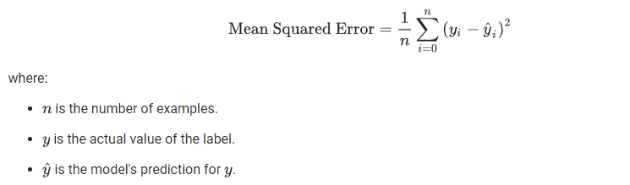

multi-class classification
In supervised learning, a classification problem in which the dataset contains more than two classes of labels. For example, the labels in the Iris dataset must be one of the following three classes:
Iris setosa, Iris virginica, Iris versicolor

numerical data
Features represented as integers or real-valued numbers.

one-hot encoding
Representing categorical data as a vector in which:
- One element is set to 1.
- All other elements are set to 0.

overfitting
Creating a model that matches the training data so closely that the model fails to make correct predictions on new data.

pipeline
The infrastructure surrounding a machine learning algorithm. A pipeline includes gathering the data, putting the data into training data files, training one or more models, and exporting the models to production.

R-squared
A regression metric indicating how much variation in a label is due to an individual feature or to a feature set.
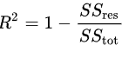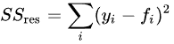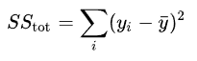

scaling
Any mathematical transform or technique that shifts the range of a label and/or feature value. Some forms of scaling are very useful for transformations like normalization.
Common forms of scaling useful in Machine Learning include:
- linear scaling (Min-Max scaling), which typically uses a combination of subtraction and division to replace the original value with a number between -1 and +1 or between 0 and 1.
- logarithmic scaling, which replaces the original value with its logarithm.
- Z-score normalization, (Standard Scaling) which replaces the original value with a floating-point value representing the number of standard deviations from that feature's mean.

sigmoid function

A mathematical function that "squishes" an input value into a constrained range, typically 0 to 1 or -1 to +1
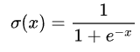

Train-test -split

Dividing the data into two distinct subsets. One used for training and the other used for testing the model after it is trained.

underfitting
Producing a model with poor predictive ability because the model hasn't fully captured the complexity of the training data.

Z-score

If the population mean and population standard deviation are known, a raw score x is converted into a standard score by^{[3]}
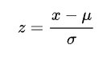
where:
μ is the mean of the population,
σ is the standard deviation of the population.

